Hash Tables and Social Media

David Graves
Colorado State University Global
CSC506
Dr. Brian Holbert
April 14, 2025

Hash Tables and Social Media
Hash tables are an important tool that can be leveraged when working with large data sets like those found on social media platforms that frequently change. Hash tables leverage hash functions to map keys with values which allows for extremely fast retrieval of information from the table provided you have the key. This eliminates the need to search across a list until the value is found and generally functions in constant time O(1) (HackerEarth.com, 2025). Hash tables are also powerful for social media engines because they easily allow for new data and content addition in real-time. One example of how the benefit of using a hash table in Facebook would be when a user adds an image to their profile with an assigned key of today’s date tied with their profile that can be stored as values. That value can then be retrieved with the key instead of having to search for the value across what could be a massive list. In other words, it assigns the image, or “needle” a specific spot in the has table, or “haystack” so it can be found easily in the future (Pfeiffer, 2022). One key benefit to using a hash table is how they can be used for personalized content recommendations. Likes and dislikes as well as other user defined preferences can be assigned values within the hash table that can be leveraged to train algorithms that can filter future content. Using the photo example again: If I am friends with the person that added the photo, the algorithm should automatically return that latest photo somewhere near the top of my personal feed. Instead of me having to search across a list to find the photo associated with one of my friends the algorithm uses my preferences and simply returns it to me. Staying in the social media realm, this can present real-world concerns like privacy, where a user may not be aware and or agree to their information being shared with third parties. Poorly constructed algorithms could also limit exposure to new content and further entrench audience thoughts and emotions with a lack of meaningful diversity. Not to diminish those real concerns, there exist other advantages to using hash tables over list search arrays like more efficient storage and greater scalability with the ability to access information from large data sets. It also should be restated that with the massive amount of data associated with social media sites that the time complexity of O(1) for retrieval within a hash table is in most cases superior to other options. Working in constant time allows users to engage with the platform with consistent results regardless of the bounds of the platform. I have provided an example of a simple hash table below (Image 1) that shows how one can be constructed with values, either integer or string assigned to keys that can then be found by their assigned value slot. I also have shared another example of a hash table (Image 2) with additional functions for adding and deleting values.
Image 1 (Simple Hash Table Construction)
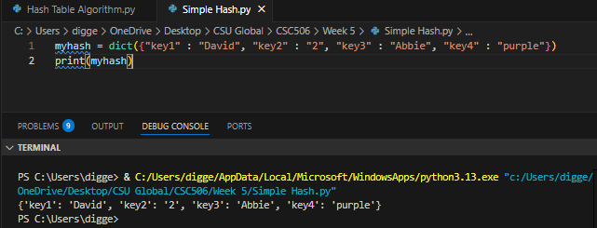

Image 2 (Hash Table w. functional examples)
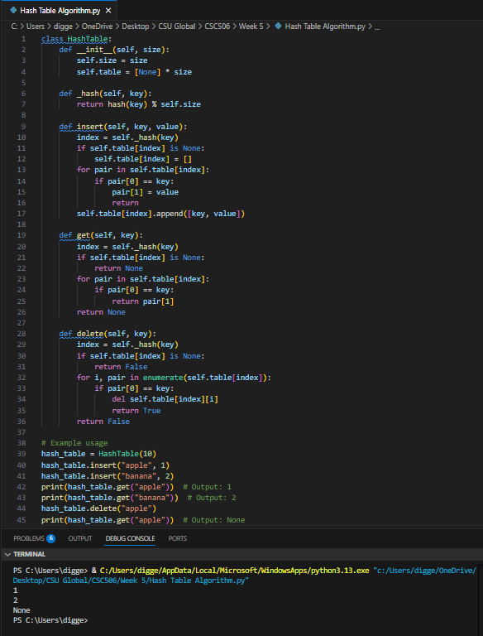

Reflection
This exercise drove home the importance of understanding the benefits and use-cases for hash tables as another tool in my growing toolbelt. Using the lens of social media brought this type of algorithm to life in a way that was accessible for me. The challenge I ran into this week was more in how detailed an algorithm I should provide as an implementation. To that end, I opted to share two different implementations, one simple one that just shows how a hash table can be constructed and another one that walks through a few additional actions like adding and deleting items to the table after being built.

References
Hackerearth.com (2025) Basics of Hash Tables.
https://www.hackerearth.com/practice/data-structures/hash-tables/basics-of-hash-tables/tutorial/
Pfeiffer, Simon (2022, June 20). Dev.to. Understanding Hash Tables and Why They are
Important.
https://dev.to/codesphere/understanding-hash-tables-and-why-they-are-important-1819

